|  |
| --- |
| **UNIVERSITY MALAYSIA TERENGGANU**  **FACULTY OF OCEAN ENGINEERING TECHNOLOGY & INFORMATICS**  **[CSM3103]**  **FRONT-END PROGRAMMING**  **LAB REPORT**  **[Lab 3]**  **Prepared by:**  Muhammad Irfan Hakim bin Saharul Redzuan  (S62113)  **Prepared for:**  Dr. Rabiei b. Mamat  [**BACHELOR OF SCIENCE COMPUTER(MOBILE COMPUTING)** ]  SEMESTER II 2022/2023 |

**Task 1** – JavaScript Function

1. Write a function to find the square of a given number

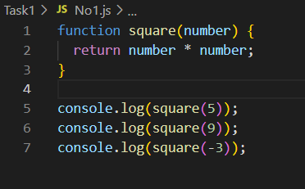

Output :

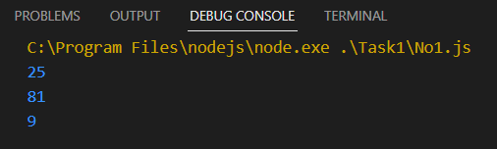

1. Write a function to find sum of cubes of two numbers

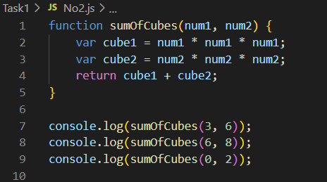

Output :

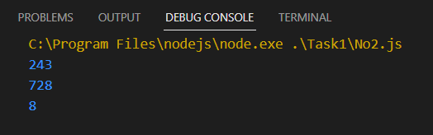

1. Write a function to reverse a number [ Hint n =12345 output : 54321 ]

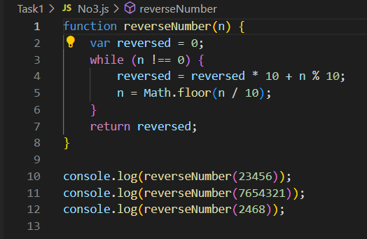

Output :

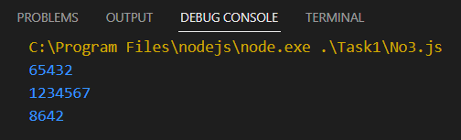

1. Write a function to print all numbers between 1 and 100 which is divisible by given number z.

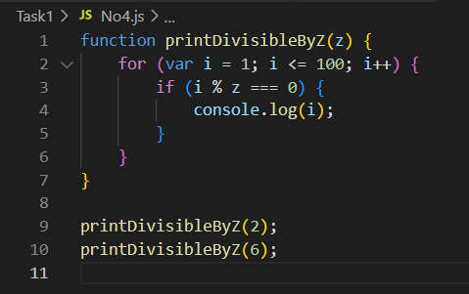

Output :

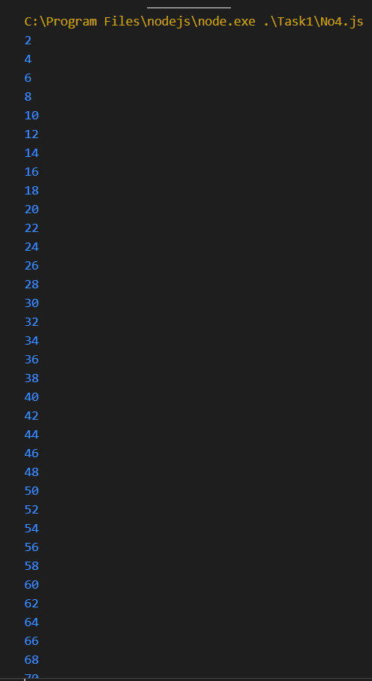

**Task 2 –** JavaScript Recursion Function

1. Write a JavaScript function to find sum of digits of a number

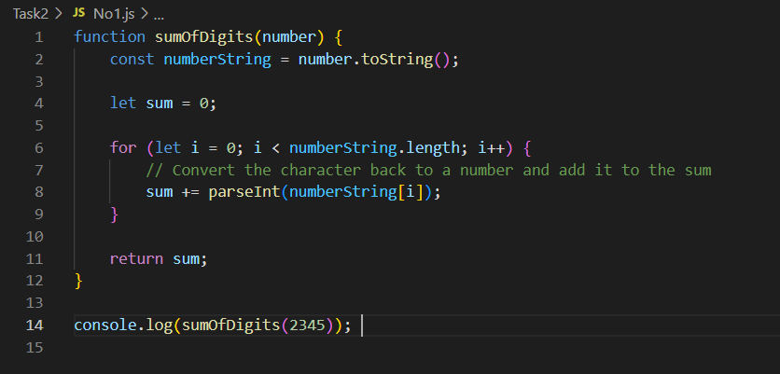

Output :

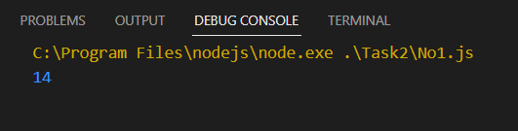

1. Write a JavaScript program to compute x raise to the power y using recursion

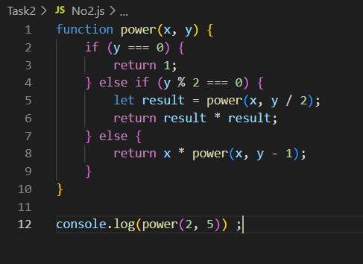

Output :

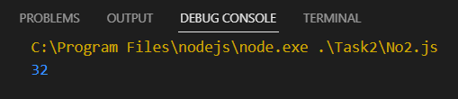

**Task 3 -** JavaScript Object and Prototype

1. Write a JavaScript program to create object product,
2. Add the property Product Name, Quantity and price.

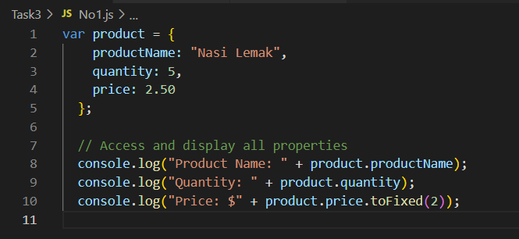

1. Access all the properties and display them.

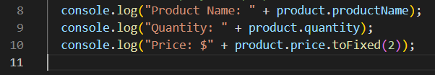

1. Write a JavaScript program to create object book
2. Add the property book name, author name

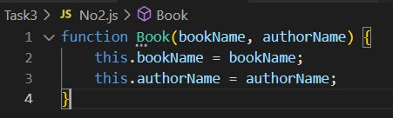

1. Add the prototype property price .



1. Display all the properties.

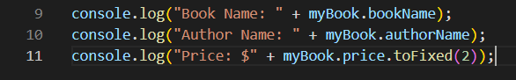

Output :

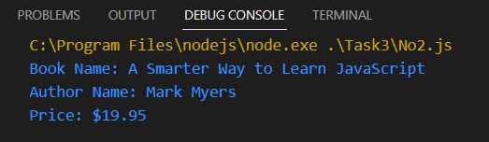

1. Write a JavaScript program to create Parent object employee (Property : Employee Name , Employee Id , Salary) and Child object Manager (Property : Manager Name , Branch). Inherit all the properties of employee and display all the properties.

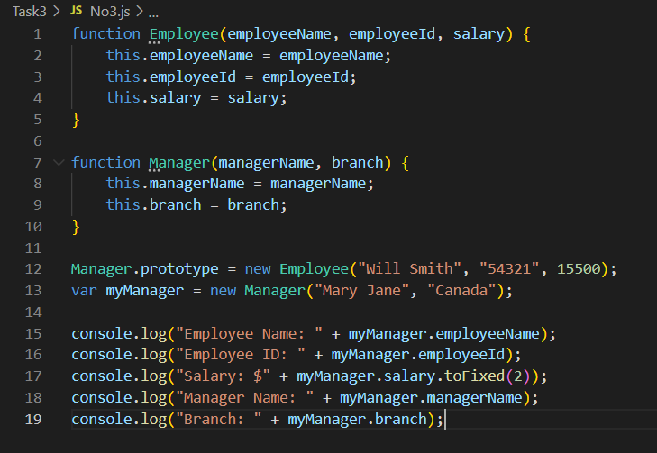

Output :

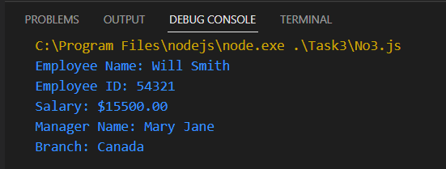

**Task 4 –** Event Manager

1. Create a HTML page with <p> paragraph. Change the paragraph color according

to the following mouse events

HTML (index.html)

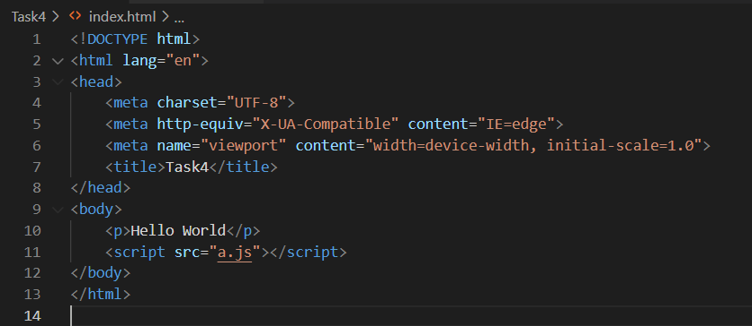

All event use the same HTML page(index.html), just change the imported javascript file.

1. Onclick, yellow background

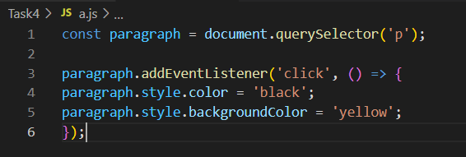

Output :

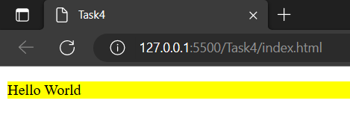

1. Ondblclick, blue background

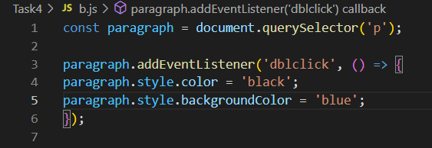

Output :

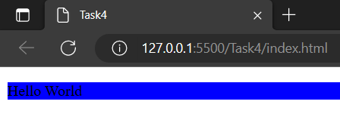

1. Onmouseover , red background

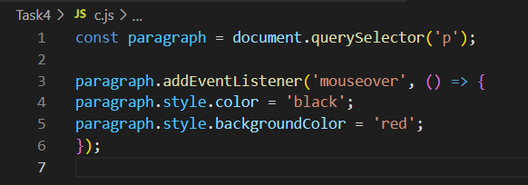

Output :

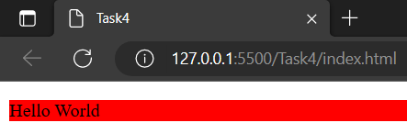

1. Onmouseout, green background

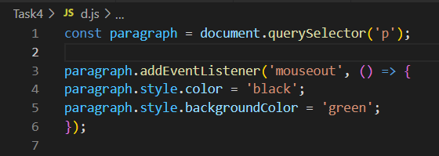

Output :

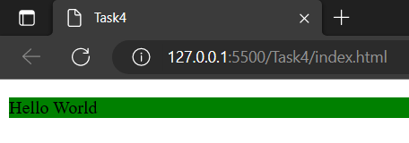

1. Create a HTML page with textfield. Show some effects on the textfield when the following events occurred:
2. Onchange

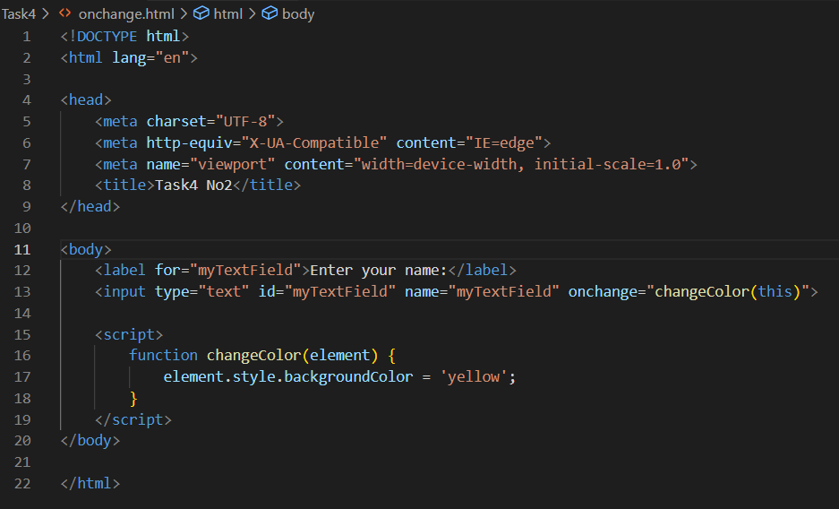

Output :

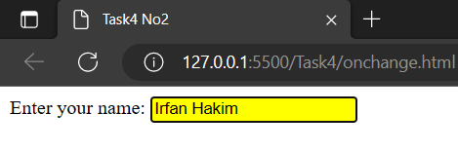

1. Onfocus

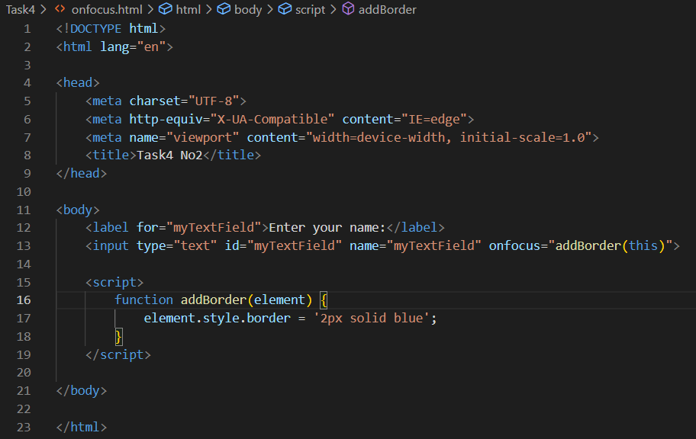

Output :

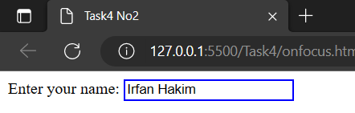

1. Onblur

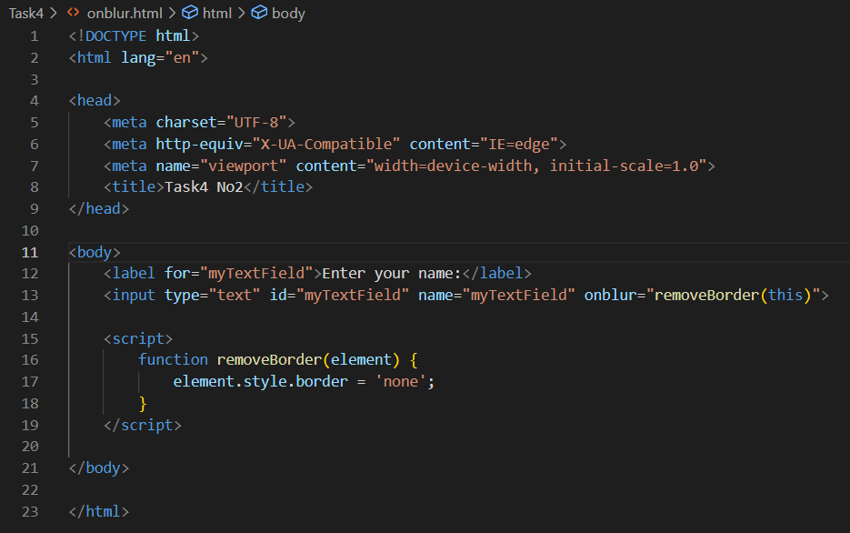

Output :

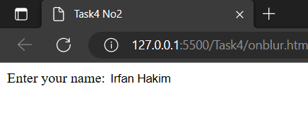

**Task 5**

HTML page (index.html)

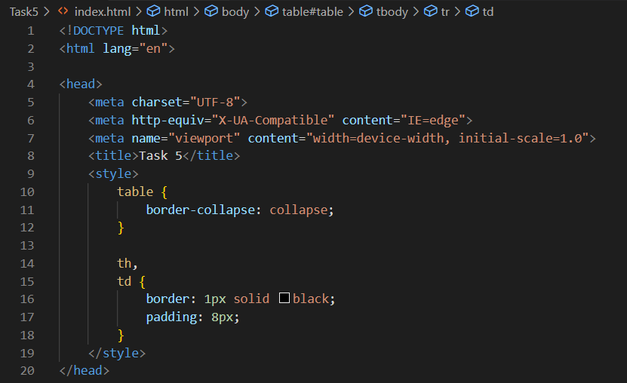

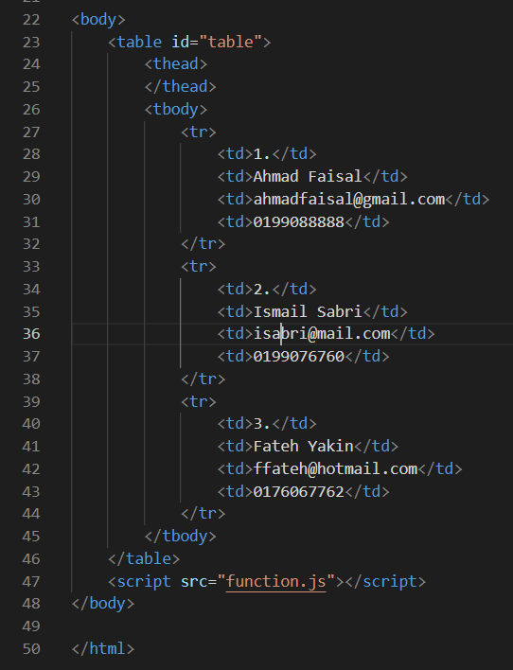

1. Using javascript add the following record into table

a. Name: Mukhriz Jamil Asoka

b. Email: mukriz@corp.jo

c. Phone: 651181187223

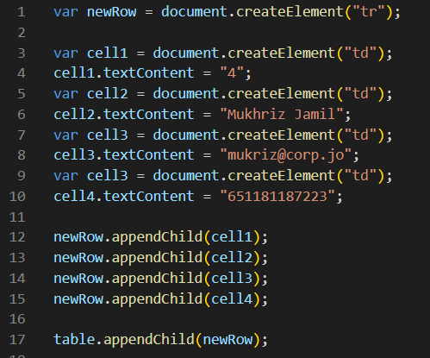

Output :

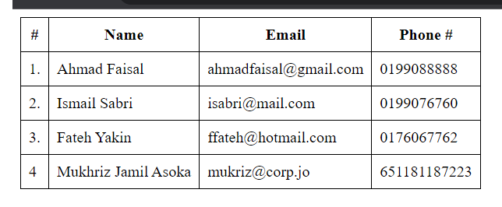

1. Using javascript add the table header as follow:
2. #, Name, Email, Phone #

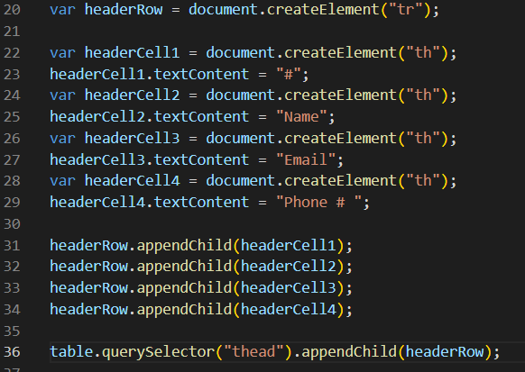

Output :



1. Using javascript, delete any row from table when clicked on that row

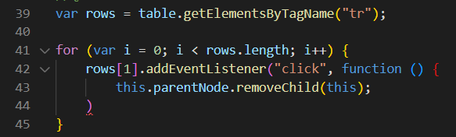

Output :

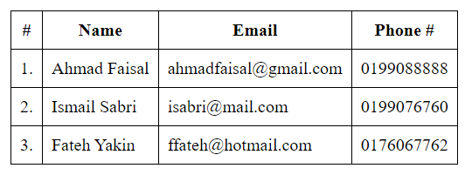

**Task 6**

Write a JavaScript program to move two small squares inside one big square in a random manner. User should be able to start and stop this animationusing button based events

HTML Page (index.html)

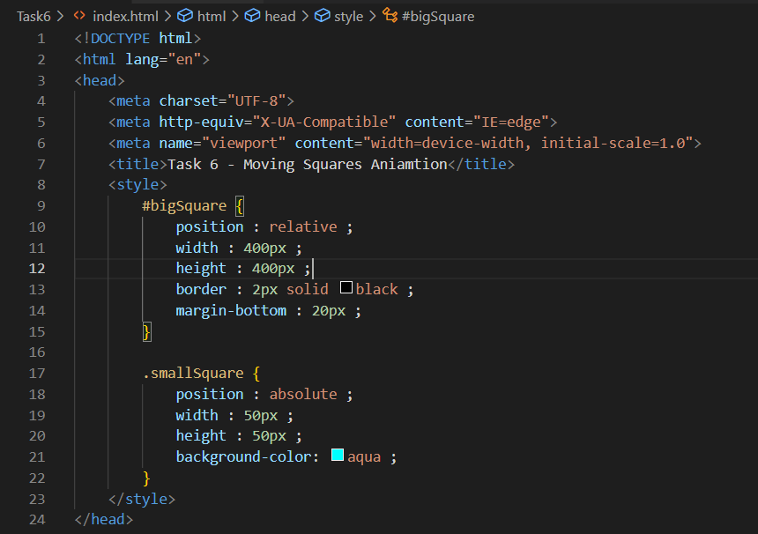

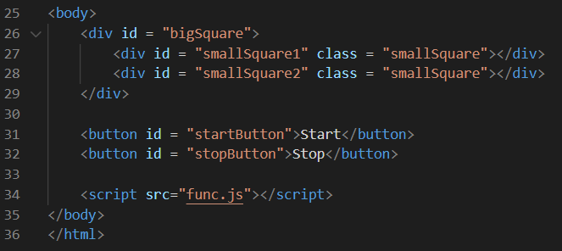

JavaScript source code

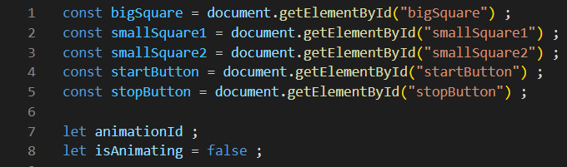

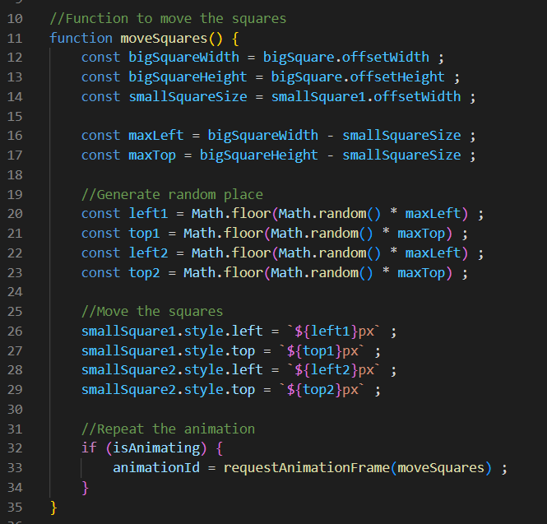

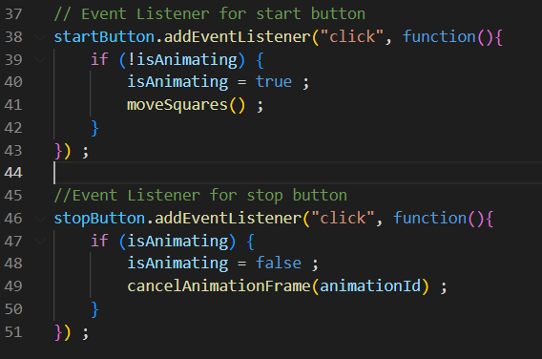

Output :

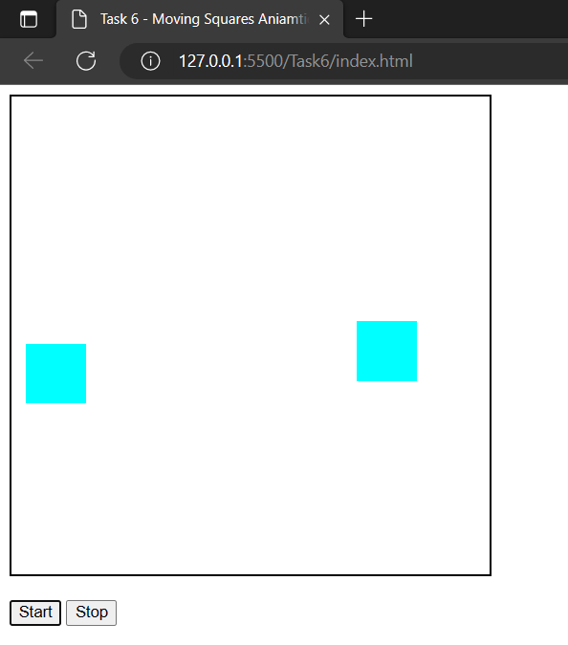

The square will move randomly when we click on the start button

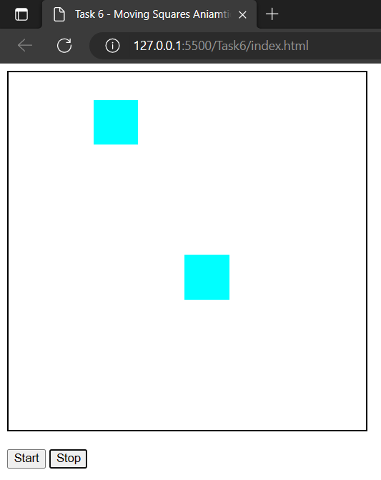

Then it will stop at random position when we click on stop button

**Github link (Source code file)**